Megan Mosier
CSD-310 Assignment 4.2
April 18, 2026

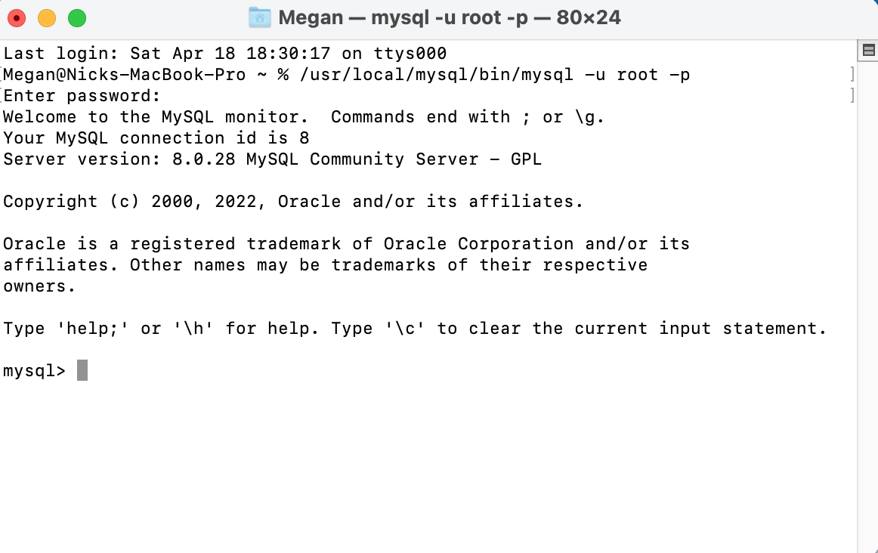
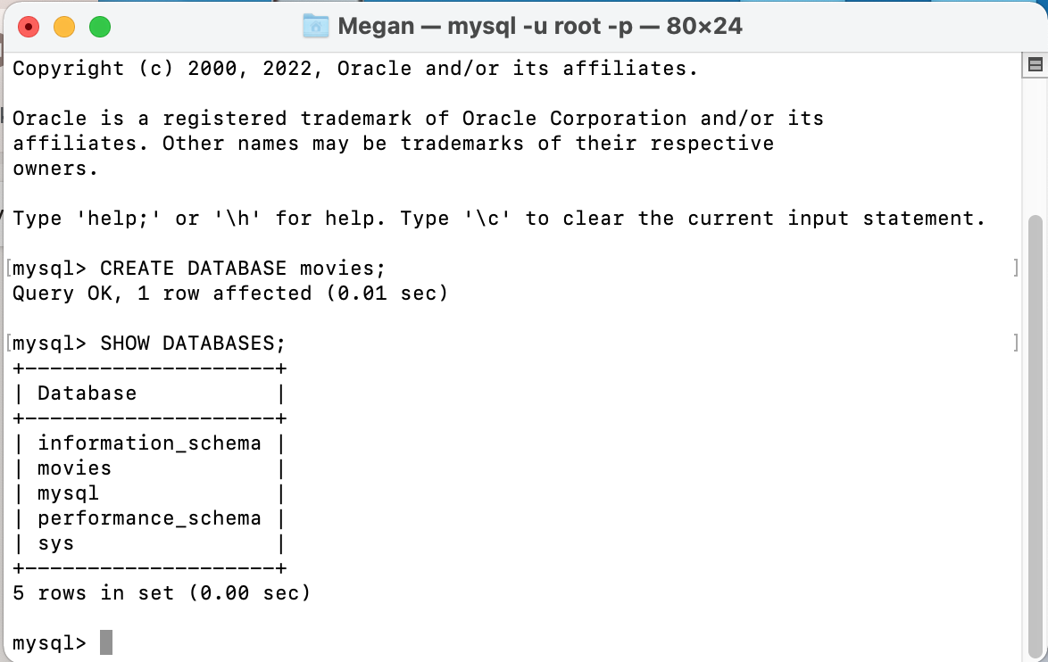

Alias With Spaces

This could be used if you have a directory of people as emergency contacts, you could create a “Emergency Contact” alias from EmergencyContact

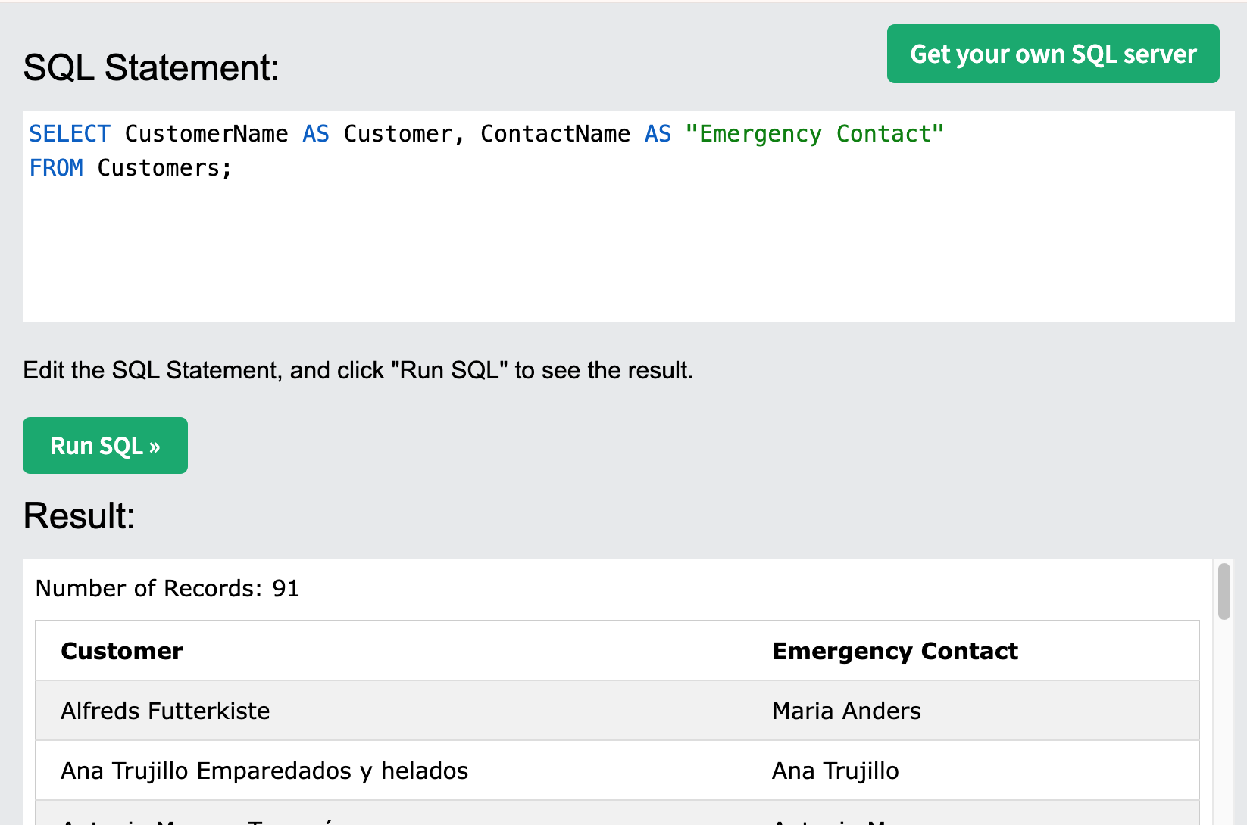

Concatenate Columns

This is great for grouping information together. Addresses are the perfect example, grouping Address, zipe code, city, state, and country together in one lump.

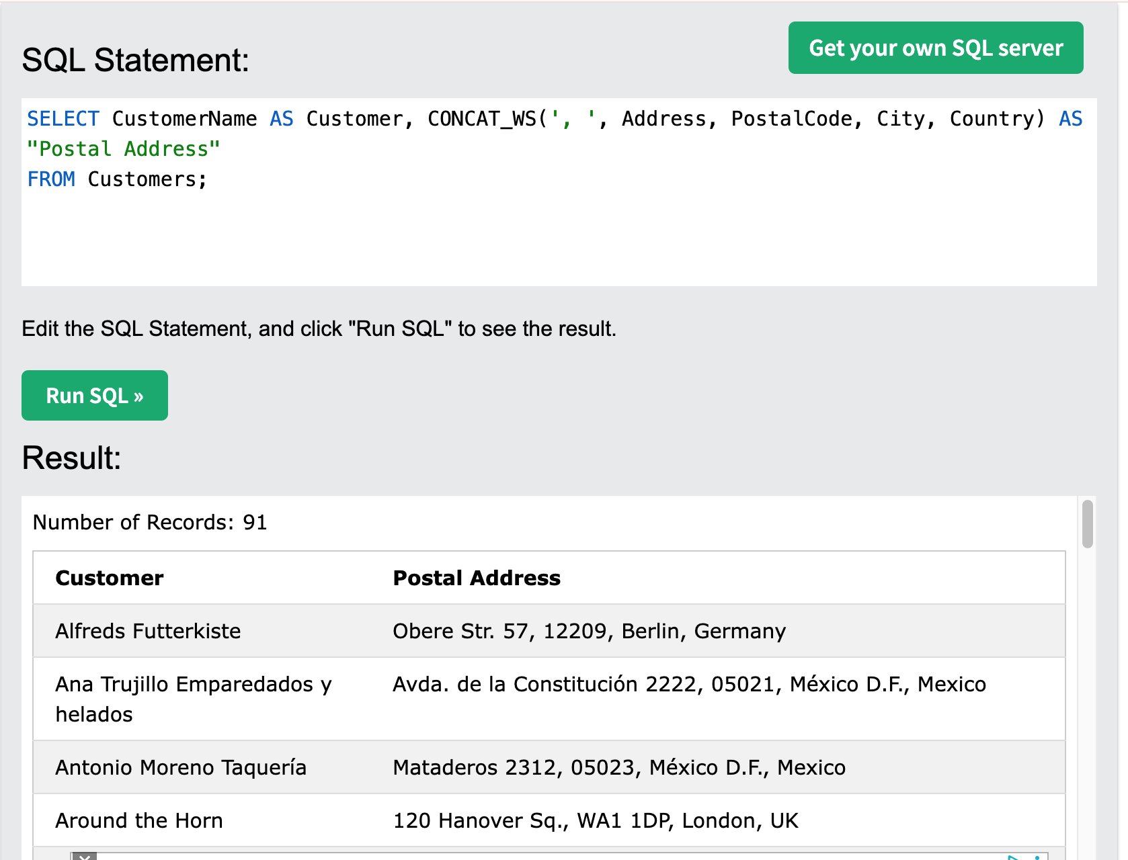

Alias for Columns

Good for relabeling columns in a table, making it easier to understand the information being provided.

